**Play Testing**

Zakaria Ahmed

**1.1 Premise**

The premise presented was for the team to be able to successfully play test a game, and Agar.io was the game that was chosen as it was entirely web based. This meant that if you had access to the internet you could play this game.

It was decided for Agar.io as the ease of access allows for the vast majority to play this as there are little game requirements as most people can play this.

**1.2 Questionnaire**

The questionnaire used for this playtest is ethics based, meaning that it stems from moral principles and is inspired by Jeremy Bentham’s Felicific Calculus. Quality in playtesting is what makes a game enjoyable; fun, thrilling, pleasure-seeking. Here is the questionnaire prompting others to describe the fun time during gameplay ;

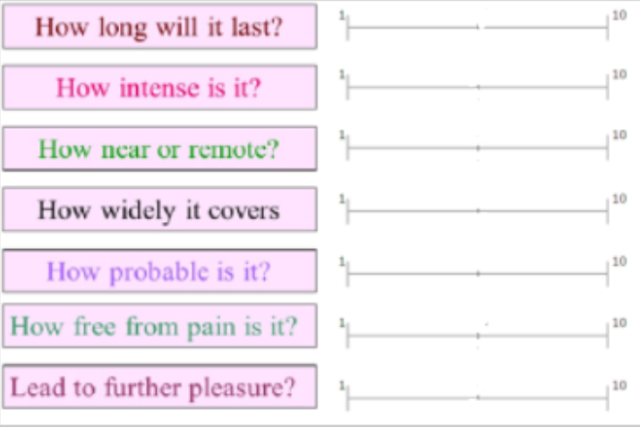

Sliders were used for each question as its seen as a more honest response

**1.3 Inspiration - Bentham’s Felicific calculus**

**Strengths**

The felicific calculus is an algorithm that was formulated by a philosopher named Jeremy Bentham. He was famous for calculating the amount of pleasure that a specific action is likely to cause. The felicific calculus could, in principle at least, determine the moral status of any considered act. This would calculate how “good” something is from these factors which is what is needed when evaluating.

**Weaknesses**

It is not clear how the Hedonic calculus resolves the problem of assessing the quantity of pleasure. For instance, how is it possible to quantify and compare intensity of pleasure with duration of pleasure? Listing the elements of pleasure does not resolve the problem of valuing playtesting but rather giving the user a better understanding.

**1.4 Results**

The play tester often kept asking questions on what the questions mean which is something the team took into account when preparing for some external playtesting. In the future the team decided that we would make the questions easier to understand to prevent confusion

Team – Zakaria Ahmed, Joshua Baker, Ben Miller